Modernizing Legacy Systems

Mitchell Fontaine
Southern New Hampshire University
CS-660: Advanced Programming Language Theory
04/03/2026

Modernizing Legacy Systems
This report outlines a comprehensive modernization proposal for the legacy inventory management service currently utilized at our company. The legacy system was initially deployed in 2008 and handles tracking warehouse inventory, fulfilling orders, updating stock levels, and generating reconciliation reports. Over the past decade, incremental patches have introduced significant technical debt and inconsistent coding styles. Current pain points include limited concurrency due to a global lock, ad hoc error handling, and manual pointer management, causing segmentation faults. The objective of this proposal is to analyze the existing ANSI C 99 implementation and recommend a modern programming paradigm and language. Implementing these changes will address existing scalability limits and prepare the system for future growth.
Abstraction and encapsulation in the current C codebase are extremely limited and rely on rudimentary techniques. The system utilizes a header and source separation approach, where files like inventory.h expose basic functions, but this fails to enforce strict interface contracts. Furthermore, the system employs a struct plus function pattern, but it lacks private fields, which allows broad global access to data. State management relies heavily on module-level global state, utilizing static file arrays to cache stock counts. This tight coupling makes the code exceptionally difficult to unit test effectively. Error handling is also problematic because it depends entirely on return codes, forcing the call site to inspect every return value. Because omissions are common, these ad hoc error handling practices often result in ignored return codes and system instability.
The legacy programming language, ANSI C 99, presents significant challenges when evaluated against modern software engineering criteria. Readability is severely compromised by mixed coding standards, heavy reliance on pointer arithmetic, and a lack of adequate comments. Maintainability suffers greatly due to the necessity of manual memory management, the prevalence of global variables, and a distinct lack of automated testing. The Free Software Foundation (2023) notes that while C provides low-level memory access, it requires developers to rigorously manage allocation to avoid severe system errors. In terms of performance, the language provides excellent raw speed, but contention surrounding a single global lock severely hinders scalability. Ecosystem support is another major weakness for this legacy implementation. While the compiler toolchain is mature, there is a distinct lack of modern libraries for handling JSON formatting or RESTful APIs.
The C 99 implementation utilizes a static type system where types are checked during the compilation process. This static nature helps detect many errors early, but it introduces the drawback of requiring a full recompilation whenever changes are made. Furthermore, the type system is inherently weak because it permits implicit casting. Allowing pointer to integer casts can easily introduce undefined behavior into the system. The implications for type safety are concerning because the language relies on manual allocation using malloc and free. This manual memory management creates a high risk of memory leaks and dangling pointers, especially since there is no built-in bounds checking. From a usability standpoint, these factors force developers to spend excessive time tracking memory rather than implementing business logic.
The redesigned system must retain essential functional requirements while drastically improving non-functional metrics. Functional requirements include managing stock adjustments by adding, removing, or transferring inventory quantities. The system must also handle order fulfillment by automatically reserving stock, decrementing it upon shipping, and rolling back operations if failures occur. Additional functional needs include producing nightly CSV reconciliation reports and emitting real-time alerts if requested stock exceeds availability. From a non-functional perspective, the system must sustain a throughput of 500 transactions per second with a latency below 75 milliseconds. It must also support horizontal scalability on commodity cloud instances, ensure high monthly uptime, and secure external traffic using modern protocols. Finally, the architecture must improve maintainability so that average new feature lead times drop below two weeks.
Evaluating different programming paradigms reveals that Object-Oriented Programming offers substantial benefits for this specific problem domain. The imperative paradigm used in the legacy codebase struggles with modularity and side effects, leading to the current synchronization issues. A functional paradigm handles immutability and side effects beautifully, but it can present a steep learning curve for teams accustomed to procedural logic. Object-Oriented Programming directly addresses the system requirements by encapsulating data and behavior into manageable, testable units. Key programming styles like modularity are achieved through class structures, replacing the legacy system's global state. Inheritance allows for the creation of extensible data models for different inventory types without duplicating code. By controlling side effects through strict method access and moving away from raw pointers, the system becomes significantly more predictable and stable.
The following pseudocode demonstrates solving the global lock bottleneck using an Object-Oriented approach with concurrent collections. Instead of locking the entire inventory, the system will lock individual items or use atomic operations. This allows multiple threads to process different orders simultaneously without blocking one another. The module encapsulates the data within an InventoryManager class. This structure directly addresses the concurrency limitations of the legacy C system.
Pseudocode:
class InventoryItem {
private String sku;
private int quantity;
private Lock itemLock;

public boolean decrementStock(int amount) {
acquireLock(itemLock);
try {
if (quantity >= amount) {
quantity = quantity - amount;
return true;
}
return false;
} finally {
releaseLock(itemLock);
}
}
}
The conceptual system outline utilizes an Object-Oriented paradigm to enforce strict boundaries between layers. Flow control is managed through a central controller that receives requests and delegates them to specific service classes. The modular structure divides the application into routing, business logic, and data access layers. Abstraction is achieved by defining interfaces for storage mechanisms, ensuring the business logic never interacts directly with raw SQL strings. Models represent the data structures, replacing the exposed structs found in the legacy codebase. Services handle the transactional logic for order fulfillment and stock adjustment. This clean separation ensures that future modifications to the database layer will not require rewriting core operational algorithms.
The table below highlights the critical differences between the original procedural paradigm and the selected Object-Oriented paradigm. These comparisons focus specifically on maintainability, team learning curve, and problem-solving effectiveness. The legacy approach clearly falls short in managing the complexity required for a scalable cloud application. Transitioning to an Object-Oriented model requires an initial investment in training. However, this investment pays off rapidly through improved code reuse and safer state management. The overall problem-solving effectiveness increases because developers can reason about isolated components rather than navigating a monolithic state.
Feature | Original Paradigm (Procedural C) | Selected Paradigm (Object-Oriented)
Maintainability | Poor due to global state, manual memory management, and high coupling. | High due to encapsulation, clear boundaries, and automated memory management.
Team Learning Curve | Low for basic syntax, but extremely high for debugging pointer issues safely. | Moderate, requires understanding of design patterns, but standardizes development.
Problem-Solving Effectiveness | Struggles with complex concurrency; manual lock management causes bottlenecks. | Excels at domain modeling; built-in concurrency controls resolve global lock issues.

When evaluating modern programming languages to support the Object-Oriented paradigm, Java and Python emerge as the strongest candidates. Python offers incredible readability and a massive ecosystem of libraries, which would speed up initial development. However, Python relies heavily on a Global Interpreter Lock, which could reintroduce concurrency bottlenecks similar to the legacy system (Python Software Foundation, 2023). Java provides robust multithreading capabilities and a strong, static type system that prevents many runtime errors (Oracle, 2023). Java also boasts excellent performance characteristics through its Just-In-Time compiler, comfortably satisfying the tight latency requirements. Therefore, Java is the recommended language for this modernization effort. Java perfectly balances the strict typing needed for enterprise inventory tracking with the advanced ecosystem required for cloud deployments.
The combination of Java and Object-Oriented Programming directly supports the long-term goals of scalability, maintainability, and efficiency. Java enables horizontal scaling across commodity cloud instances by cleanly integrating with modern web frameworks like Spring Boot. Maintainability is vastly improved because the strict Object-Oriented structure enforces the separation of concerns. Automated garbage collection eliminates the segmentation faults and memory leaks that plagued the legacy C codebase (Oracle, 2023). Development efficiency increases because developers no longer need to write boilerplate SQL queries directly in the business logic. Robust exception handling mechanisms also replace the fragile return code checks, reducing the mental burden on engineers. Ultimately, these factors will allow the team to meet the goal of delivering new features in less than a two-week sprint.
The following Java code snippet demonstrates modern control flow and exception handling. It replaces the legacy approach of checking multiple return codes and pseudo error enums. Instead of manual locking, it leverages standard concurrency utilities and structured try-catch blocks. This ensures that resources are always properly released, even if an unexpected error occurs during processing. This structure directly addresses the previous issues associated with omitted return code inspections.
Pseudocode:
public void processOrder(Order ord) throws OrderProcessingException {
if (ord == null) {
throw new IllegalArgumentException("Order cannot be null");
}
try {
boolean locked = inventoryLock.tryLock(5, TimeUnit.SECONDS);
if (!locked) {
throw new TimeoutException("Could not acquire inventory lock");
}
// ... update stock counts ...
} catch (InterruptedException | TimeoutException e) {
throw new OrderProcessingException("Order failed due to lock contention", e);
} finally {
inventoryLock.unlock();
}
}
Validating data formats using regular expressions is significantly more streamlined in Java compared to the legacy POSIX implementation. The original C code required manual compilation, execution, and freeing of regex structures. In Java, standard utility packages handle memory management and complex pattern matching automatically. The following snippet demonstrates validating the same SKU pattern consisting of three letters, a dash, and four digits. It compiles the pattern once as a constant to optimize performance during repeated validations.
Pseudocode:
import java.util.regex.Pattern;
import java.util.regex.Matcher;

public class SkuValidator {
// SKU pattern: 3 letters, dash, 4 digits
private static final Pattern SKU_PATTERN = Pattern.compile("^[A-Z]{3}-[0-9]{4}$");

public boolean hasValidSku(String sku) {
if (sku == null) {
return false;
}
Matcher matcher = SKU_PATTERN.matcher(sku);
return matcher.matches();
}
}
The redesigned architecture employs a layered microservices approach to ensure modularity and scalability (Fowler, 2020). Incoming traffic is routed through an API Gateway configured with TLS to meet security requirements. The core logic is housed within the Java Inventory Service. This service interacts with a highly available distributed database, completely removing the legacy SQL string embeddings. Asynchronous background workers handle tasks like generating the nightly CSV reconciliation reports. A caching layer is also introduced to minimize database reads for high-frequency stock checks.
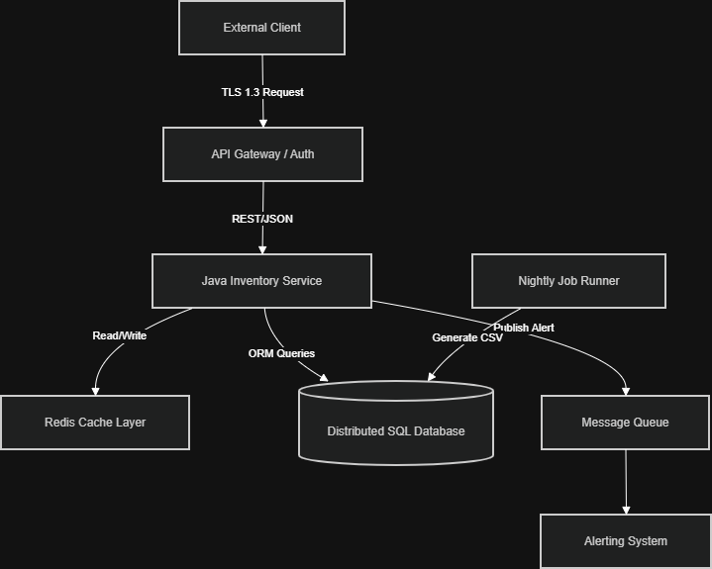
Selecting Java and an Object-Oriented paradigm involves several calculated tradeoffs. Regarding performance, Java introduces a slight memory overhead compared to the peak RAM consumption of the original C application. However, the massive gain in horizontal scalability easily justifies this increased memory footprint. Extensibility is heavily prioritized in this design, allowing new item types and workflows to be added with minimal friction. The tooling ecosystem is vastly superior, providing sophisticated debuggers, profiling tools, and automated testing frameworks out of the box. Finally, while the team will need to transition away from C, Java skills are ubiquitous in the industry, making future hiring and team scaling much easier. The temporary decrease in velocity during the learning phase is far outweighed by the long-term stability of the platform.

References
Fowler, M. (2020). Microservices. MartinFowler.com. https://martinfowler.com/articles/microservices.html
Free Software Foundation. (2023). The GNU C Reference Manual. GNU Operating System. https://www.gnu.org/software/gnu-c-manual/
Oracle. (2023). The Java Tutorials: Concurrency. Oracle Documentation. https://docs.oracle.com/javase/tutorial/essential/concurrency/
Python Software Foundation. (2023). Global Interpreter Lock. Python Wiki. https://wiki.python.org/moin/GlobalInterpreterLock

